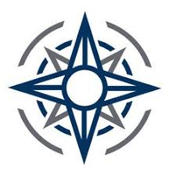108th Community Action Team Resource List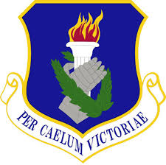
The objective of the Community Action Team is to integrate wing helping agencies into one seamless team providing the right help at the right time to our service members, families and DOD civilians.

AFRPO Airmen and Family Readiness Program Office
(609) 754-4479

PHP Psychological Health Program
(609) 754-2159
On Call via Command Post 754-2127

CHP Chaplain’s Office (609) 754-2496
On Call via Command Post 754-2127

SARC Sexual Assault Response Coordinator
(609) 694-9426

MEO Military Equal Opportunity
(609) 754-2580

HRA Human Resources Advisor
(609) 754-6937

FSC First Sergeant’s Council
On Call First Sergeant via Command Post 754-2127

MDG Medical Group
(609) 754-2635

ROM Retention and Education Office
(609) 754-1260

JAG Judge Advocate (Legal)
(609) 754-3870
IG Inspector General (Complaints)
(609) 754-4670

MOS Military OneSource
(800) 342-9647

